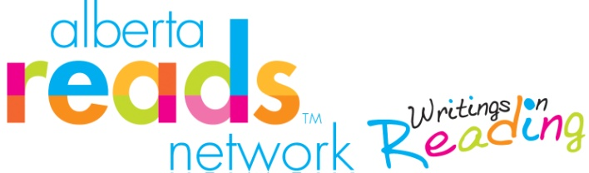
Building young brains can be as simple as using the 3 Ts!
When it comes to interacting with your baby or young child, there are three easy ways for parents to harness the power of their words to build their children’s brains and shape their futures.
Tune In
Notice what your baby or child is focused on and talk about that. Respond when your child communicates ideas, questions and emotions – including when your baby coos or cries.
Talk More
Narrate day-to-day routines, such as diaper changes. Use details: “Let mommy take off your diaper. Oh so wet! And smell it. So stinky!” Or when tooth brushing: “How many teeth do you have now? Let’s count them together . . . 1, 2, 3 . . .”
Take Turns
Keep the conversation going. Respond to your child’s sounds, gestures and eventually words – and give them time to respond to you. Ask lots of questions that require more than ‘yes’ or ‘no’ answers.
Adapted from the book, Thirty Million Words: Building a Child’s Brain the 3 Ts are based on research that found children in some households heard 30 million fewer words by age three than children in other homes. These children also heard a smaller variety of words and fewer words of encouragement. This ‘word gap’ can exist in families of any socioeconomic status but, on average, children from low-income homes may be most at risk of hearing less words.
As a parent, you are your child’s first and most important teacher. Using the 3 Ts can help you expose your child to more words. And, children who hear more words are better prepared when they enter school. And, by grade three children who have heard more words at home tend to have bigger vocabularies and are stronger readers.
Other tips include:
- If you are bilingual, talk to your child mostly in your first language – it will be richer. But, also be sure to expose your child to the language of the broader community; here in Western Canada, that’s English.
- Embrace baby-talk – not made-up words, but a melodic pitch, positive tone, and sing-song rhythm.
- Read aloud to your child. Even babies benefit. And, as you child gets older and can read themselves, read aloud to them from books above their own reading level. It introduces new vocabulary and makes these words familiar when they later encounter them in print.
With thanks to: www.thirtymillionwords.org
For resources to help your child develop critical literacy skills and a joy of reading, visit our website. The CBC Calgary / Calgary Reads Big Book Sale, happens May 13 to 15, 2016. This is Calgary Reads signature fundraising event. Find full event details and how to donate books on our website. www.calgaryreads.com

